

**CN LAB PROJECT**

CISCO PACKET TRACER



August 2, 2023

M. MUNTAZER MEHDI

20F-0290

Subnetting:

|  |  |  |  |  |  |  |  |
| --- | --- | --- | --- | --- | --- | --- | --- |
| Subnet Name/id | Needed Host id | Total Host id | Network id | First Useable IP | Last Useable IP | Mask | Broadcast id |
| Lab | 100000 | 131070 | 99.0.0.0 | 99.0.0.1 | 99.1.255.254 | /15 | 99.1.255.255 |
| Administration | 25000 | 32766 | 99.2.0.0 | 99.2.0.1 | 99.2.127.254 | /17 | 99.2.127.255 |
| CS | 25000 | 32766 | 99.2.128.0 | 99.2.128.1 | 99.2.255.254 | /17 | 99.2.255.255 |
| EE | 25000 | 32766 | 99.3.0.0 | 99.3.0.1 | 99.3.127.254 | /17 | 99.3.127.255 |
| Director | 5 | 6 | 99.3.128.0 | 99.3.128.1 | 99.3.128.6 | /29 | 99.3.128.7 |

|  |  |
| --- | --- |
| Subnet Mask | Allocated |
| 255.254.0.0 | YES, Lab Department |
| 255.255.128.0 | YES, Admin Department |
| 255.255.128.0 | YES, CS Department |
| 255.255.128.0 | YES, EE Department |
| 255.255.248.0 | YES, Director Department |

Topology:

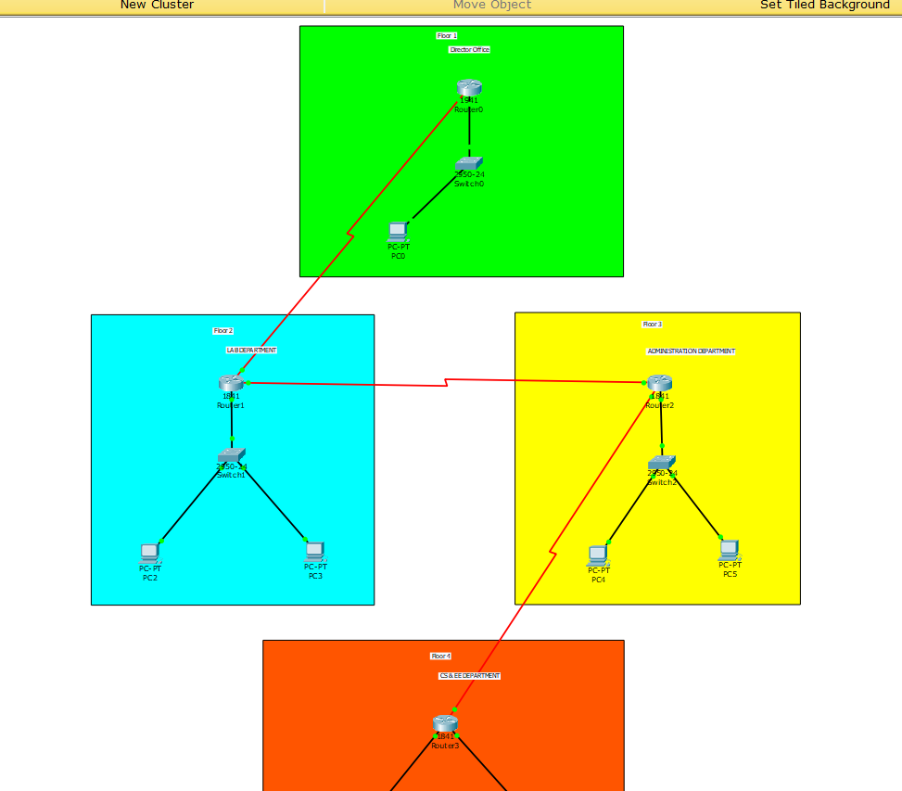

Director Office:

* Ip to Fast Ethernet 0/0:

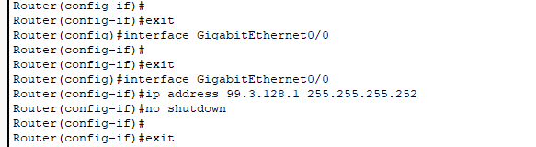

* Banner

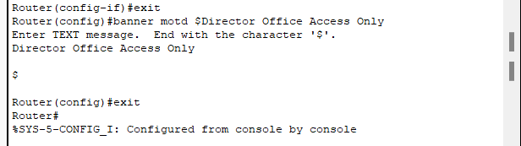

* Static Ip:

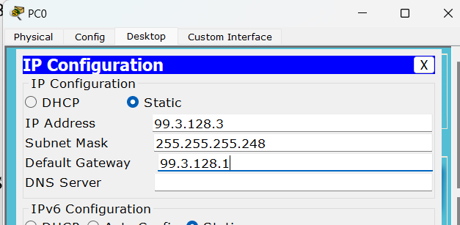

Lab Department:

* DHCP Configuration on Router:

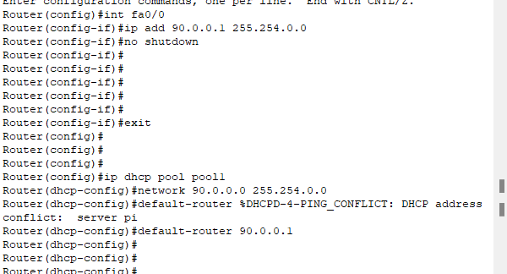

* Dynamic IP to PC:

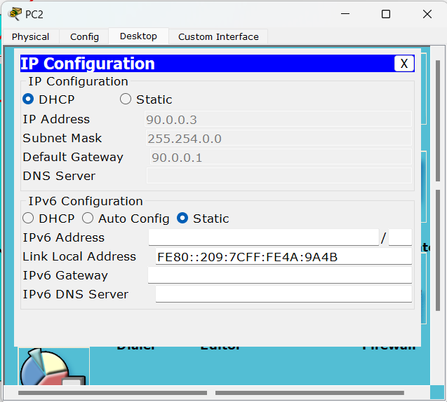

Administration Department:

* DHCP Configuration on Router:

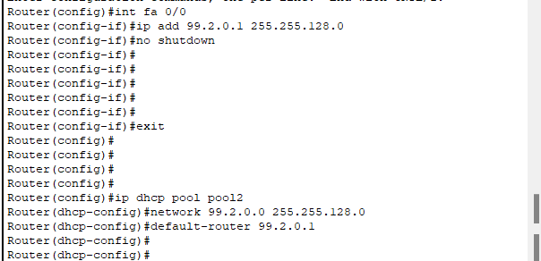

* Dynamic IP to PC:

CS & SE Department:

* DHCP Configuration on Router:
* CS DEPT:

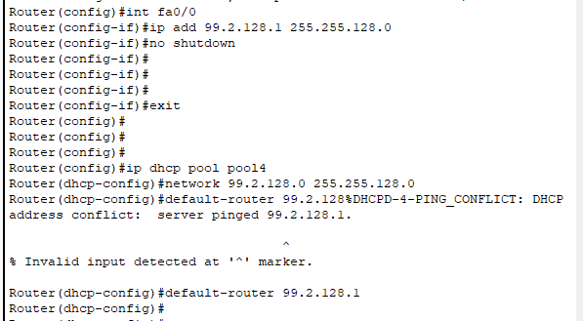

* EE DEPT:

* Dynamic IP to PC:
* CS DEPT:

* EE DEPT:

**OSPF:**

* Director office:

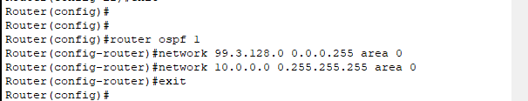

* Lab Department:

* Admin department:

* CS & EE Department:

**SSH:**

* Director Office:

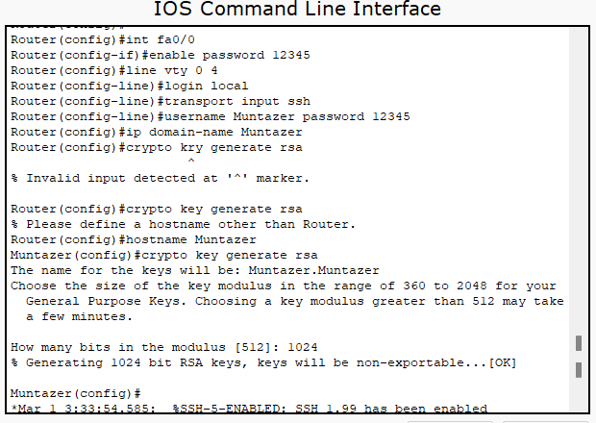

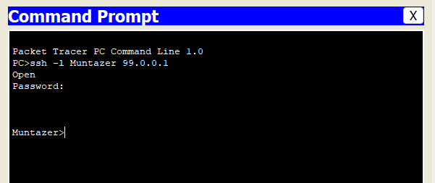

**NAT:**

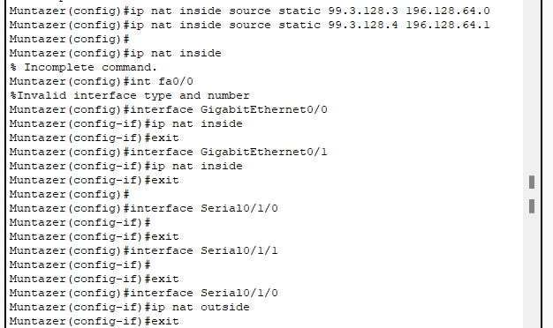

**VLAN:**



